
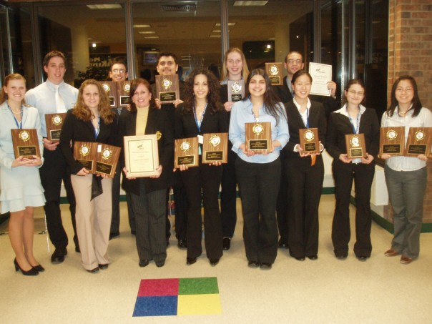
School of Business Students:
Be part of the tradition…
Interest Session:

Date: Wednesday, February 13, 2008
Time 4:00 pm
Location: Student Center 209

SFB Funded
Presented By TCNJ Chapter
NEW JERSEY STATE LEADERSHIP CONFERENCE
Future Business Leaders of America

